**Roll No : B-44**

**Name : Onkar S Nora**

**Batch : TC3**

**Assignment Title :** To study and use matplotlib library to visualize different types of data and their relationship using line chart, bar chart, scatter plot and pie chart.

**Python Matplotlib : Types of Plots**

There are various plots which can be created using python matplotlib. Some of them are listed below:

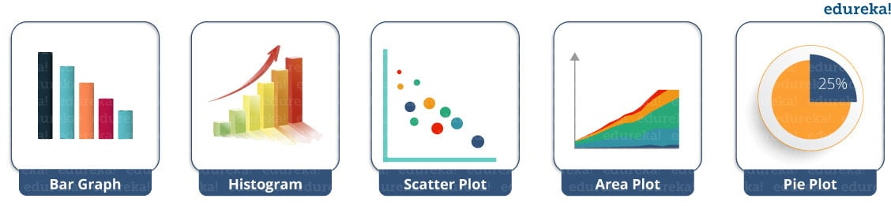

I will demonstrate each one of them in detail.

But before that, let me show you very basic codes in python matplotlib in order to generate a simple graph.

|  |  |
| --- | --- |
| 1  2  3  4  5  6  7  8  9 | from matplotlib import pyplot as plt     #Plotting to our canvas     plt.plot([1,2,3],[4,5,1])     #Showing what we plotted     plt.show() |

Output –  
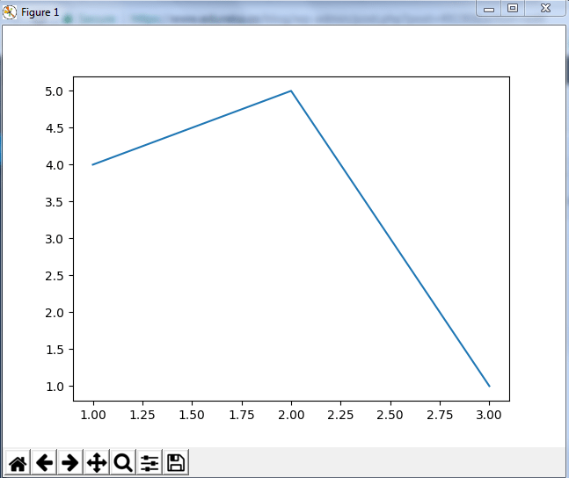

So, with three lines of code, you can generate a basic graph using python matplotlib. Simple, isn’t it?  
Let us see how can we add title, labels to our graph created by python matplotlib library to bring in more meaning to it. Consider the below example:

|  |  |
| --- | --- |
| 1  2  3  4  5  6  7  8  9 | from matplotlib import pyplot as plt    x = [5,2,7]  y = [2,16,4]  plt.plot(x,y)  plt.title('Info')  plt.ylabel('Y axis')  plt.xlabel('X axis')  plt.show() |

Output –

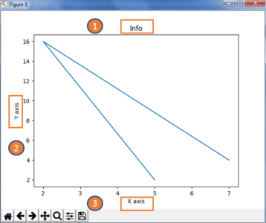

You can even try many styling techniques to create a better graph. What if you want to change the width or color of a particular line or what if you want to have some grid lines, there you need styling! So, let me show you how to add style to a graph using python matplotlib. First, you need to import the style package from python matplotlib library and then use styling functions as shown in below code:

|  |  |
| --- | --- |
| 1  2  3  4  5  6  7  8  9  10  11  12  13  14  15  16 | from matplotlib import pyplot as plt  from matplotlib import style    style.use('ggplot')  x = [5,8,10]  y = [12,16,6]  x2 = [6,9,11]  y2 = [6,15,7]  plt.plot(x,y,'g',label='line one', linewidth=5)  plt.plot(x2,y2,'c',label='line two',linewidth=5)  plt.title('Epic Info')  plt.ylabel('Y axis')  plt.xlabel('X axis')  plt.legend()  plt.grid(True,color='k')  plt.show() |

Output –  
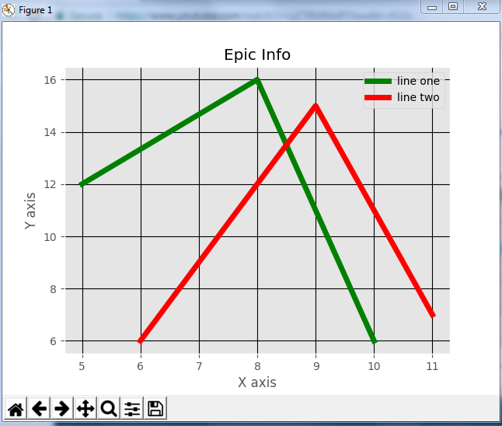

Next in this python matplotlib blog, we will understand different kinds of plots. Let’s start with bar graph!

**Python Matplotlib: Bar Graph**

First, let us understand why do we need a bar graph. A bar graph uses bars to compare data among different categories. It is well suited when you want to measure the changes over a period of time. It can be represented horizontally or vertically. Also, the important thing to keep in mind is that longer the bar, greater is the value. Now, let us practically implement it using python matplotlib.

|  |  |
| --- | --- |
| 1  2  3  4  5  6  7  8  9  10  11 | from matplotlib import pyplot as plt    plt.bar([0.25,1.25,2.25,3.25,4.25],[50,40,70,80,20],  label="BMW",width=.5)  plt.bar([.75,1.75,2.75,3.75,4.75],[80,20,20,50,60],  label="Audi", color='r',width=.5)  plt.legend()  plt.xlabel('Days')  plt.ylabel('Distance (kms)')  plt.title('Information')  plt.show() |

Output –

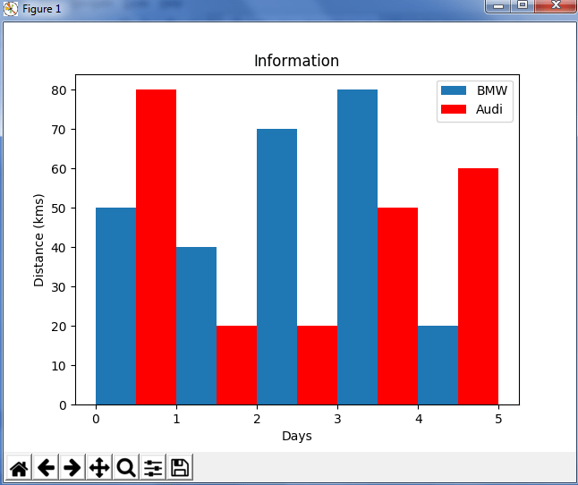

In the above plot, I have displayed the comparison between the distance covered by two cars BMW and Audi over a period of 5 days. Next, let us move on to another kind of plot using python matplotlib – Histogram.

**Python Matplotlib – Histogram**

Let me first tell you the difference between a bar graph and a histogram. Histograms are used to show a distribution whereas a bar chart is used to compare different entities. Histograms are useful when you have arrays or a very long list. Let’s consider an example where I have to plot the age of population with respect to bin. Now, bin refers to the range of values that are divided into series of intervals. Bins are usually created of the same size. In the below code, I have created the bins in the interval of 10 which means the first bin contains elements from 0 to 9, then 10 to 19 and so on.

|  |  |
| --- | --- |
| 1  2  3  4  5  6  7  8 | import matplotlib.pyplot as plt  population_age = [22,55,62,45,21,22,34,42,42,4,2,102,95,85,55,110,120,70,65,55,111,115,80,75,65,54,44,43,42,48]  bins = [0,10,20,30,40,50,60,70,80,90,100]  plt.hist(population_age, bins, histtype='bar', rwidth=0.8)  plt.xlabel('age groups')  plt.ylabel('Number of people')  plt.title('Histogram')  plt.show() |

Output –

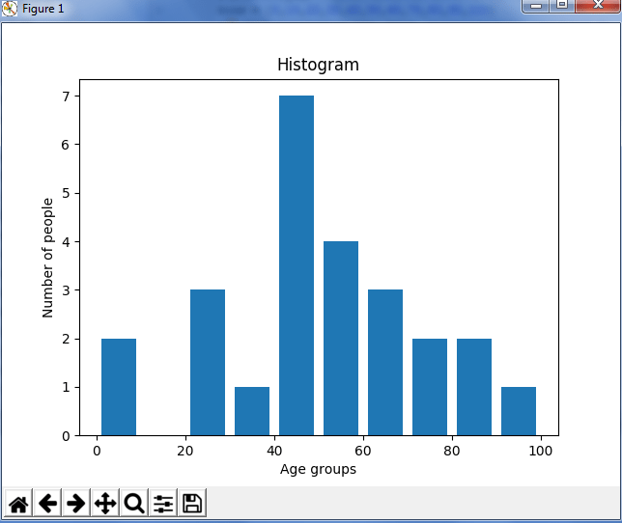  
As you can see in the above plot, we got age groups with respect to the bins. Our biggest age group is between 40 and 50.

**Python Matplotlib : Scatter Plot**

Usually we need scatter plots in order to compare variables, for example, how much one variable is affected by another variable to build a relation out of it. The data is displayed as a collection of points, each having the value of one variable which determines the position on the horizontal axis and the value of other variable determines the position on the vertical axis.

Consider the below example:

|  |  |
| --- | --- |
| 1  2  3  4  5  6  7  8  9  10  11  12  13  14 | import matplotlib.pyplot as plt  x = [1,1.5,2,2.5,3,3.5,3.6]  y = [7.5,8,8.5,9,9.5,10,10.5]    x1=[8,8.5,9,9.5,10,10.5,11]  y1=[3,3.5,3.7,4,4.5,5,5.2]    plt.scatter(x,y, label='high income low saving',color='r')  plt.scatter(x1,y1,label='low income high savings',color='b')  plt.xlabel('saving*100')  plt.ylabel('income*1000')  plt.title('Scatter Plot')  plt.legend()  plt.show() |

Output –

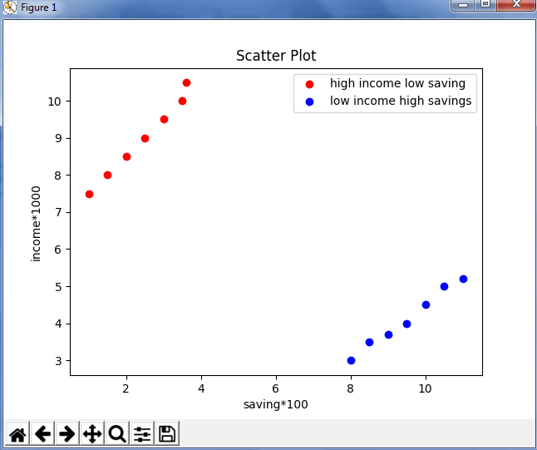  
As you can see in the above graph, I have plotted two scatter plots based on the inputs specified in the above code. The data is displayed as a collection of points having ‘high income low salary’ and ‘low income high salary’.

Next, let us understand area plot or you can also say Stack plot using python matplotlib.

**Python Matplotlib : Pie Chart**

A pie chart refers to a circular graph which is broken down into segments i.e. slices of pie. It is basically used to show the percentage or proportional data where each slice of pie represents a category. Let’s have a look at the below example:

|  |  |
| --- | --- |
| 1  2  3  4  5  6  7  8  9  10  11  12  13  14  15  16  17  18  19  20  21  22 | import matplotlib.pyplot as plt    days = [1,2,3,4,5]    sleeping =[7,8,6,11,7]  eating = [2,3,4,3,2]  working =[7,8,7,2,2]  playing = [8,5,7,8,13]  slices = [7,2,2,13]  activities = ['sleeping','eating','working','playing']  cols = ['c','m','r','b']    plt.pie(slices,    labels=activities,    colors=cols,    startangle=90,    shadow= True,    explode=(0,0.1,0,0),    autopct='%1.1f%%')    plt.title('Pie Plot')  plt.show() |

Output –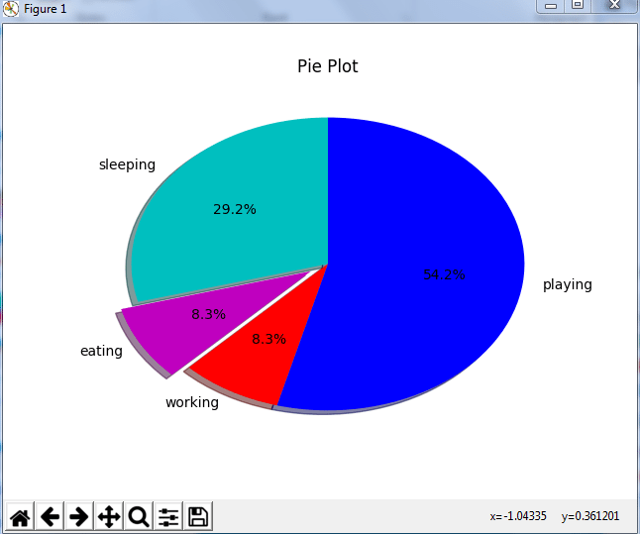

In the above pie chart, I have divided the circle into 4 sectors or slices which represents the respective category (playing, sleeping, eating and working) along with the percentage they hold. Now, if you have noticed these slices adds up to 24 hrs, but the calculation of pie slices is done automatically for you. In this way, pie charts are really useful as you don’t have to be the one who calculates the percentage or the slice of the pie.

Next in python matplotlib, let’s understand how to work with multiple plots.

**Python Matplotlib : Working With Multiple Plots**

I have discussed about multiple types of plots in python matplotlib such as bar plot, scatter plot, pie plot, area plot etc. Now, let me show you how to handle multiple plots. For this, I have to import numpy module which I discussed in my previous blog on [Python Numpy](https://www.edureka.co/blog/python-numpy-tutorial/). Let me implement it practically, consider the below example.

|  |  |
| --- | --- |
| 1  2  3  4  5  6  7  8  9  10  11  12 | import numpy as np  import matplotlib.pyplot as plt    def f(t):      return np.exp(-t) * np.cos(2*np.pi*t)  t1 = np.arange(0.0, 5.0, 0.1)  t2 = np.arange(0.0, 5.0, 0.02)  plt.subplot(221)  plt.plot(t1, f(t1), 'bo', t2, f(t2))  plt.subplot(222)  plt.plot(t2, np.cos(2*np.pi*t2))  plt.show() |

Output -

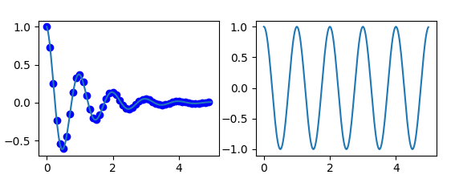

The code is pretty much similar to the previous examples that you have seen but there is one new concept here i.e. subplot. The subplot() command specifies numrow, numcol, fignum which ranges from 1 to numrows*numcols. The commas in this command are optional if numrows*numcols<10. So subplot (221) is identical to subplot (2,2,1). Therefore, subplots helps us to plot multiple graphs in which you can define it by aligning vertically or horizontally. In the above example, I have aligned it horizontally.

Apart from these, python matplotlib has some disadvantages. Some of them are listed below:

* They are heavily reliant on other packages, such as NumPy.
* It only works for python, so it is hard or impossible to be used in languages other than python. (But it can be used from Julia via PyPlot package).

**Conclusion :**

we studied use matplotlib library to visualize different types of data and their relationship using line chart, bar chart, scatter plot and pie chart.